
Narrogin Senior High School
English Learning Area

EXAMINATION ANSWER BOOKLET

NAME: __________________________________________________

TEACHER: _______________________________________________

ENGLISH
YEAR 10
2021

INSTRUCTIONS TO CANDIDATES

Write all responses in this booklet.

Write the number of the question next to the beginning of your answer.

All writing must be done in blue or black pen only.

Do not remove pages from this answer book. Extra pages may be added.

SECTION |  | COMMENT
READING | /50
WRITING | /50

Time allowed for this paper
Reading time before commencing work: 5 minutes
Working time for paper: Two Lessons
Structure of this paper

Section | Number of questions available | Number of questions to be attempted | Suggested working time
Section One: Reading | 11 | 11 | One lesson
Section One: Writing | 1 | 1 | One lesson

Instructions to candidates:

1. The rules for the conduct of Semester Examinations are set by the school. Sitting this assessment implies that you agree to abide by these rules.

2. Write your answers in the standard answer book provided.

3. Your responses should address the specific requirements of the questions asked and you should follow any specific instructions given.

4. During the reading time you may not write.

SECTION ONE: READING

Allow approximately 50 minutes to complete this section. (50 marks)

Read the following extract and respond to the comprehension questions.
The Beach
This story is told by a young mother who lives in Vietnam. Her husband and her little daughter, Nai, are setting out on a dangerous journey by sea to escape the war in their homeland. The mother has chosen to stay behind in the village to help the others escape safely.
The beach was deserted now. I glanced at my watch. It was now half past seven, just one
more hour until time. The sun sank lower into the sea, dyeing its blood red. The sky was tinted
with purple and orange. A few gulls cried mournfully and the wind blew hard. I held on close to
my daughter and hugged her even more tightly. My face burned.
‘Nai,’ I said shakily. ‘Listen to me carefully. In a minute daddy’s boat is going to come in.
You will swim out with Cut and Minh.’
‘We’re going to escape?’ came Nai’s voice excitedly.
‘Yes, we’re escaping. But I can’t swim out. I have to go home to turn on the lights and make
the people not suspicious. Then tonight daddy will bring come in with the boat and I’ll be there.’
Why do I have to lie to her, even at this moment? I glanced at my watch. 7.45. Then my
heart stopped. Voices carried by the wind reached my ears. People appeared from beyond the
sand dunes. My heart leapt. Their faces were familiar and most of the voices were laughter of
children.
‘It’s eight o’clock,’ I whispered.
The figure of a man sitting across the sand must have been looking at his watch too. For at
that precise moment he took out a lighter and struck. The signal was carried out. I strained my
eyes and swept my vision backwards and forwards on what I guessed was the horizon. A tiny
light appeared, flashing in the darkness. Swiftly and silently, the moment had come.
‘Nai,’ I called. She ran towards me. I think she knew the danger as well. I gathered her in
my arms and held her. My heart shattered into little pieces. There was a lump in my throat.
‘See you tonight,’ she whispered. My throat was blocked.
‘Go,’ I managed to croak. Her little legs turned and accelerated. She soon reached the
others. Together they entered the water. I watched their heads bobble until they disappeared
into the night.
‘Goodbye,’ I whispered and turned my head to realise that the sun had long gone over the horizon. I wondered silently: when will I see her again?

- Look at Lines 1-3. What time of day is it at the start of the passage? What evidence from the text tells you this? (2 marks)

- What language is used to describe this time of day? What effect does this description have on the reader? (4 marks)

- Write down two quotations from the first paragraph which make the beach sound like a sad and lonely place. Explain how the writer’s use of language helps to create this effect. (6 marks)

- In your own words, explain the escape plan in lines 6-11. (4 marks)

- How does Nai feel about the escape plan? What evidence from the text tells you this? (2 marks)

- What is the lie that Nai’s mother tells her? (2 marks)

- Look at lines 12-28. How does the writer show that the narrator is deeply unhappy about being parted from her daughter? (6 marks)

- The writer uses pathetic fallacy to emphasise how the mother feels in the last paragraph. A pathetic fallacy is when a writer gives human feelings, responses or actions to inanimate things or animals. How is the setting described? How does this reflect the mother’s feelings? (4 marks)

Read the following extract from Lord of the Flies and respond to the comprehension questions. At this point in the novel, a group of boys are stranded on a desert island and two groups have developed, one led by Jack and one led by Ralph.

Evening was come, not with calm beauty but with the threat of violence.
Jack spoke.
“Give me a drink.”
Henry brought him a shell and he drank, watching Piggy and Ralph over the jagged rim. Power lay in the brown swell of his forearms: authority sat on his shoulder and chattered in his ear like an ape.
“All sit down.”
The boys ranged themselves in rows on the grass before him but Ralph and Piggy stayed a foot lower, standing on the soft sand. Jack ignored them for the moment, turned his mask down to the seated boys and pointed at them with the spear.
“Who’s going to join my tribe?”
Ralph made a sudden movement that became a stumble. Some of the boys turned toward him.
“I gave you food,” said Jack, “and my hunters will protect you from beast. Who will join my tribe?”
“I’m chief,” said Ralph, “because you chose me. And we were going to keep the fire going. Now you run after food—”
“You ran yourself!” shouted Jack. “Look at that bone in your hands!”
Ralph went crimson.
“I said you were hunters. That was your job.”
Jack ignored him again.
“Who’ll join my tribe and have fun?”
“I’m chief,” said Ralph tremulously. “And what about the fire? And I’ve got the conch.”
“You haven’t got it with you,” said Jack, sneering. “You left it behind. See, clever? And the conch doesn’t count at this end of the island—”
All at once the thunder struck. Instead of the dull boom there was a point of impact in the explosion.
“The conch counts here too,” said Ralph, “and all over the island.”
“What are you going to do about it then?”
Ralph examined the ranks of boys. There was no help in them and he looked away, confused and sweating. Piggy whispered.
“The fire—rescue.”
“Who’ll join my tribe?”
“I will.”
“Me.”
“I will.”
“I’ll blow the conch,” said Ralph breathlessly, “and call an assembly.”
“We shan’t hear it.”
Piggy touched Ralph’s wrist.
“Come away. There’s going to be trouble. And we’ve had our meat.”
There was a blink of bright light beyond the forest and the thunder exploded again so that a littlun started to whine. Big drops of rain fell among them making individual sounds when they struck.
“Going to be a storm,” said Ralph, “and you’ll have rain like when we dropped here. Who’s clever now? Where are your shelters? What are you going to do about that?”
The hunters were looking uneasily at the sky, flinching from the stroke of the drops. A wave of restlessness set the boys swaying and moving aimlessly. The flickering light became brighter and the blows of the thunder were only just bearable. The littluns began to run about, screaming.
Jack leapt on to the sand.
“Do our dance! Come on! Dance!”
He ran stumbling through the thick sand to the open space of rock beyond the fire. Between the flashes of lightning the air was dark and terrible; and the boys followed him, clamorously. Roger became the pig, grunting and charging at Jack, who side-stepped. The hunters took their spears, the cooks took spits, and the rest clubs of firewood. A circling movement developed and a chant. While Roger mimed the terror of the pig, the littluns ran and jumped on the outside of the circle. Piggy and Ralph, under the threat of the sky, found themselves eager to take a place in this demented but partly secure society. They were glad to touch the brown backs of the fence that hemmed in the terror and made it governable.
“Kill the beast! Cut his throat! Spill his blood!”
The movement became regular while the chant lost its first superficial excitement and began to beat like a steady pulse. Roger ceased to be a pig and became a hunter, so that the center of the ring yawned emptily. Some of the littluns started a ring on their own; and the complementary circles went round and round as though repetition would achieve safety of itself. There was the throb and stamp of a single organism.
The dark sky was shattered by a blue-white scar. An instant later the noise was on them like the blow of a gigantic whip. The chant rose a tone in agony.
“Kill the beast! Cut his throat! Spill his blood!”
Now out of the terror rose another desire, thick, urgent, blind.
“Kill the beast! Cut his throat! Spill his blood!”
Again the blue-white scar jagged above them and the sulphurous explosion beat down. The littluns screamed and blundered about, fleeing from the edge of the forest, and one of them broke the ring of biguns in his terror.
“Him! Him!”
The circle became a horseshoe. A thing was crawling out of the forest. It came darkly, uncertainly. The shrill screaming that rose before the beast was like a pain. The beast stumbled into the horseshoe.
“Kill the beast! Cut his throat! Spill his blood!”
The blue-white scar was constant, the noise unendurable. Simon was crying out something about a dead man on a hill.
“Kill the beast! Cut his throat! Spill his blood! Do him in!”

◊

- Define the following italicised words. Use context clues from the passage to determine the meaning if you are unsure. (2 marks each - 8 marks total )

Word | Definition
said Ralph tremulously
in this demented…society
the complementary circles
the shrill screaming

- ‘Evening was come, not with calm beauty but with the threat of violence.’ What language in the text demonstrates a ‘threat of violence’ and how does it accomplish this? Identify and explain three examples. (6 marks)

- What differences between Ralph and Jack can be seen in this passage? What do these differences tell the reader about each character? (6 marks)

END OF SECTION ONE

SECTION TWO: WRITING

Allow approximately 50 minutes to complete this section. (50 marks)

Compose an imaginative or persuasive text that uses language features and text structures in response to the image below.

- Language features: The features of language that support meaning (for example, sentence structure, noun group/phrase, vocabulary, punctuation, figurative language). Choices in language features and text structures together define a type of text and shape its meaning. These choices vary according to the purpose of a text, its subject matter, audience, and mode or medium of production.

- Text structures: The ways in which information is organised in different types of texts (for example, chapter headings, subheadings, tables of contents, indexes and glossaries, overviews, introductory and concluding paragraphs, sequencing, topic sentences, taxonomies, cause and effect). Choices in text structures and language features together define a text type and shape its meaning.

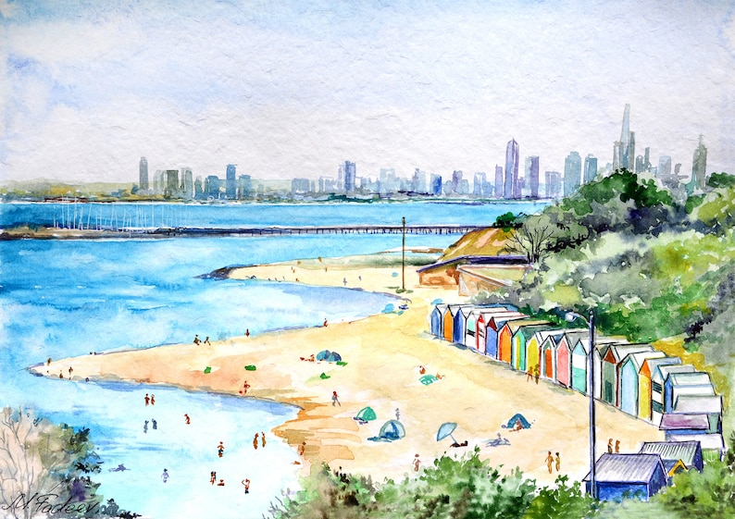

- Plan your story.

- Write your story.
Mapping/brainstorm

END OF SECTION TWO

